Canadian Institute of Technology

Faculty of engineering

Department of software engineering



SOFTWAREREQUIREMENTS SPECIFICATION

A project submitted in partial fulfillment of the requirements for the Fundamentals of Programming II

course in second year bachelor.

**By**

Aleksandros Iljas

**Supervised by**

Bledi Kazia

**Employee Management System**

**Abstract:**

The Employee Management System is a Java application that interacts with a database to manage employee information. The system provides functionalities such as adding employees, editing employee details, and deleting employees. It incorporates a login screen to ensure secure access to the application. The application uses a graphical user interface (GUI) with various components such as buttons, combo boxes, and text fields. The results of queries executed by the application are displayed in a JTable.

**Description of Functions:**

**Login Screen:**

• The user enters their username and password.

• The entered credentials are compared with the database records for authentication.

• If the login is successful, the user gains access to the application.

• If the login fails, an error message is displayed.

• After logging in, the user is lead to the main GUI page

**Add Employee:**

• the user can select the "Add Employee" option where the user enters the employee's name, surname, occupation, salary, date, and ID into text fields.

•On clicking the "Add" button, the employee's information is inserted into the database.

•The user receives a success message if the operation is successful.

**Edit Employee:**

•The user selects the "Edit Employee" option from the main menu.

•A combo box displays the names of existing employees.

•On selecting an employee from the combo box, the employee's details appear in the respective text fields.

•The user can modify the information in the text fields.

•Clicking the "Save" button updates the employee's details in the database.

•A success message is displayed upon successful update.

**Delete Employee:**

•The user chooses the "Delete Employee" option from the main menu.

•The combo box shows the names of existing employees.

•Selecting an employee from the combo box allows the user to delete them from the database.

•Clicking the "Delete" button removes the employee's record.

•A success message is shown upon successful deletion.

**Pictured view**

**Login Screen:**

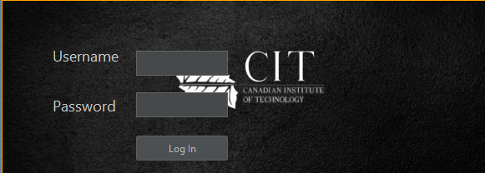

**Login Screen database:**

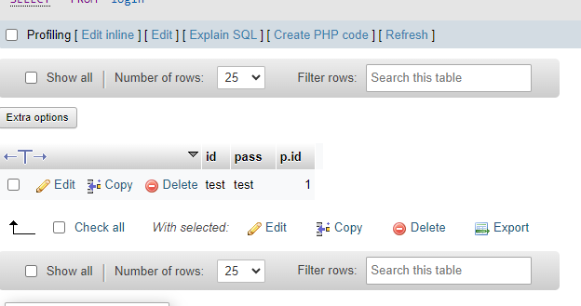

**Main GUI page**



**Add Employee:**

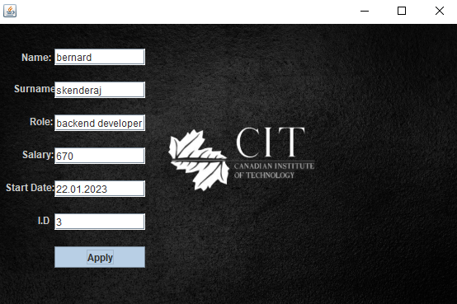

**Database of Add Employee: after apply button**

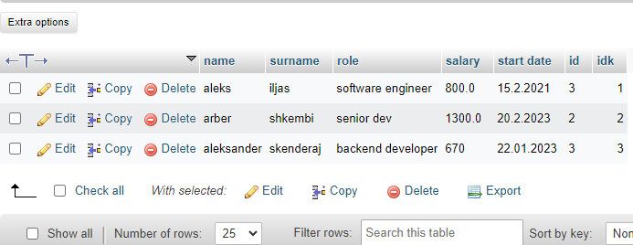

**Edit Employee:**

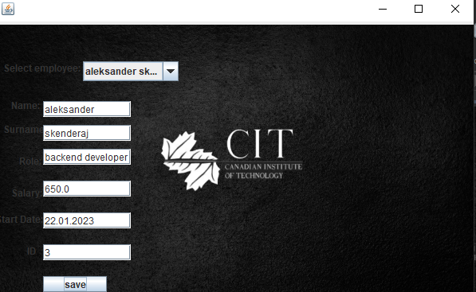

Database after salary was changed from 670 to 650:

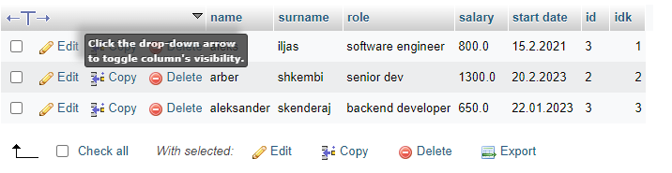

**Delete Employee:**



**Database after deleting Arber shkembi :**